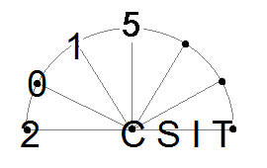 | The 17th International Workshop on Computer Science and Information Technologies  (CSIT’2015)  September 22 - 26, 2015  Rome, Italy
Уважаемый участник международной конференции CSIT’2015 просим вас заполнить следующую форму:
NAME
UNIVERSITY
DEPARTMENT
APPOINTMENT
ACADEMIC DEGREE
ADDRESS
TEL
E-MAIL
FORM OF PARTICIPANCE (FULL/ONLY PUBLICATION)
REPORT TITLE

Return this form by email, mail or fax to:
CSIT 2015 Workshop Secretariat,
e-mail: csit.usatu@gmail.com

Fax: +7 347 2737717
Tel: +7 347 2737967

